8 Series User-Programmable LED/Pushbutton Template Technical Note
Publication reference: GET-20035A
Revision Date: March 22nd, 2018
Copyright © 2025 GE Vernova

Description
The 8 Series faceplate options M and G provide two columns of 7 LED indicators, and 3 LED pushbutton indicators. The “IN SERVICE” (LED 1) and the “PICKUP” (LED 4) indicators from the first LED column are non-programmable, and all other LEDs are configurable. Three pushbuttons are available for programming. Refer to the instruction manual for additional details.
The 8 Series faceplate option A provides one column of 12 LEDs, and 10 LED pushbutton indicators. The “IN SERVICE” (LED 1) and the “PICKUP” (LED 4) indicators are non-programmable, and all other LEDs are configurable. 10 pushbuttons are available for programming. Refer to the instruction manual for additional details.
The user-programmable LEDs provide an easy method of displaying digital information (ON, OFF) from FlexLogic™ operands. Typical applications include breaker status and protection element status.
The user-programmable pushbuttons provide an easy and error-free method of entering digital state (ON, OFF) information. Typical applications include breaker control and setpoint group changes.

Template
The user-programmable LED and user-programmable pushbutton templates are shown on the following pages. Click on the text fields within each label to edit. Each line of text should not exceed the label width limits. The labels are sized to align with the LEDs.
When the custom labels text entry is completed, save this document to a secure location before printing.
The 3 Pushbutton faceplates (options M and G) come with a label removal tool for removing the LED labels and pushbutton label. See pages 4 and 5 for detailed instructions.
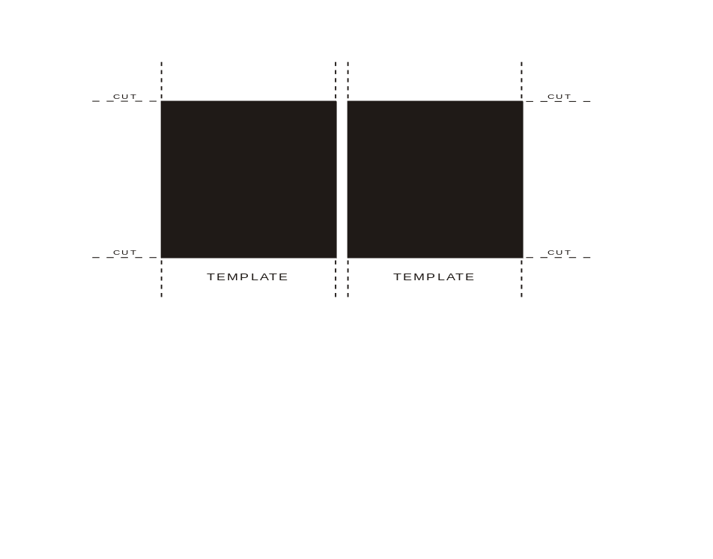
IN SERVICE
LED 2
LED 3
PICKUP
LED 5
LED 6
LED 7

LED 8
LED 9
LED 10
LED 11
LED 12
LED 13
LED 14

Figure 1: User-Programmable LED template, Faceplate options M (3 PB Membrane) and G (3 PB Rugged)

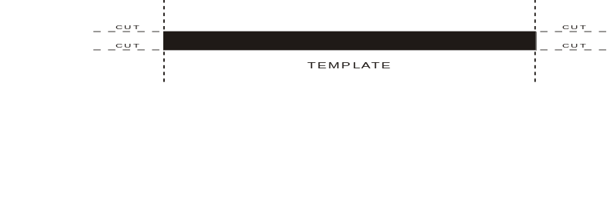
PB2

PB1

PB3

Figure 2: User-Programmable Pushbutton template, Faceplate options M (3 PB Membrane) and G (3 PB Rugged)
The 10 Pushbutton faceplate (option A) does not require a special tool to remove and replace the labels.

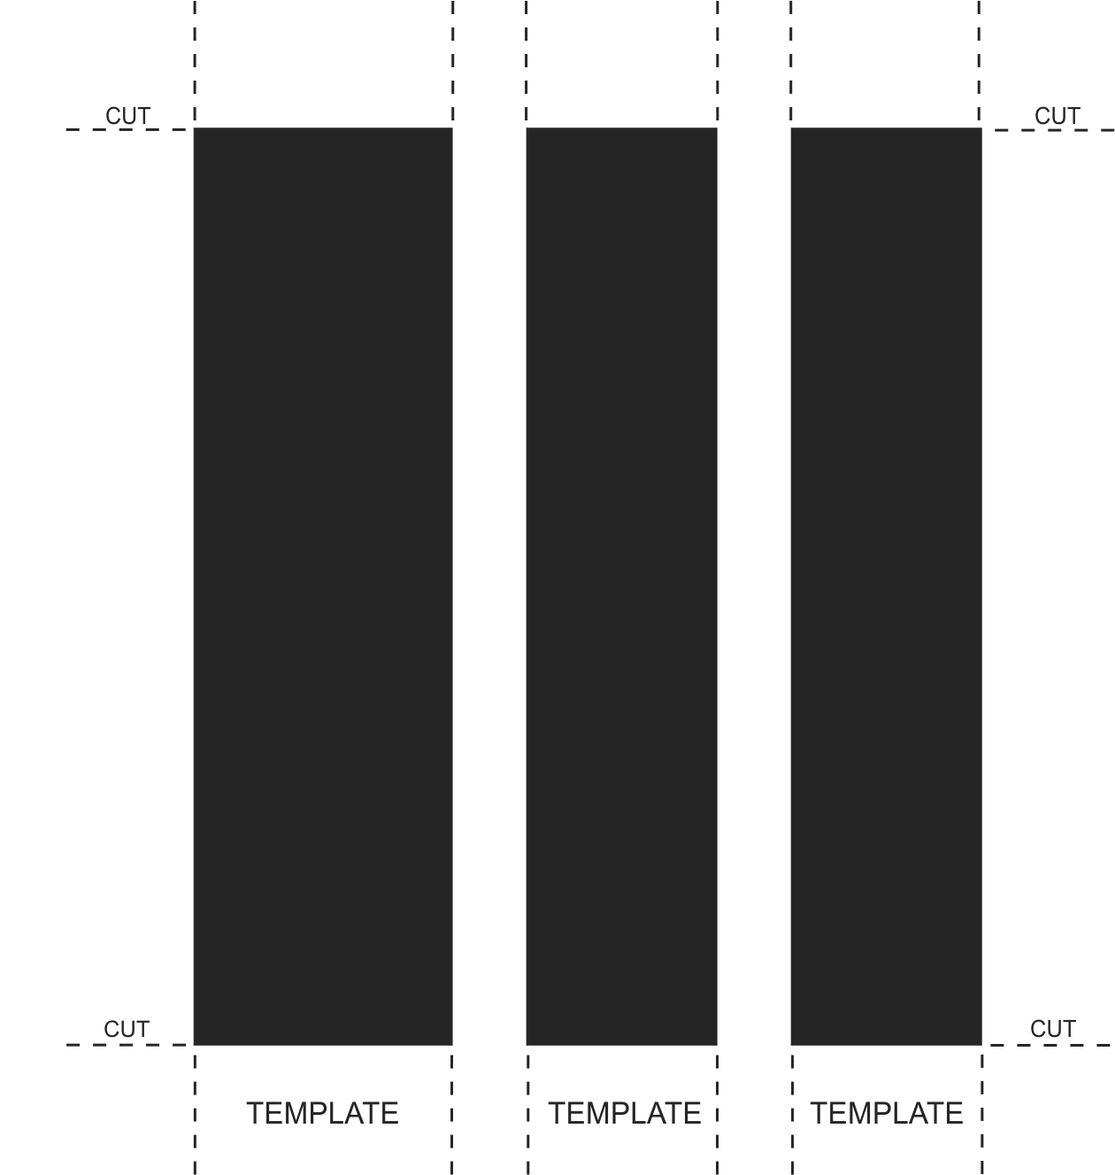
CUSTOM PB10
CUSTOM PB6
CUSTOM PB9
CUSTOM PB8
CUSTOM PB7
CUSTOM PB1
CUSTOM PB5
CUSTOM PB4
CUSTOM PB3
CUSTOM PB2
IN SERVICE
LED 2
LED 3
PICKUP
LED 5
LED 6
LED 7
LED 8
LED 9
LED 10
LED 11
LED 12

Figure 3: User-Programmable LED and Pushbutton template, Faceplate option A (10 PB Membrane)

LED Label Replacement
The following procedure describes how to replace the LED labels using the label removal tool.
- Bend the tabs of the tool upwards as shown in the image.

- Slide the label removal tool under the LED label as shown in the next image. Make sure the bent tabs are pointing away from the relay. Move the tool inside until the tabs enter the pocket.

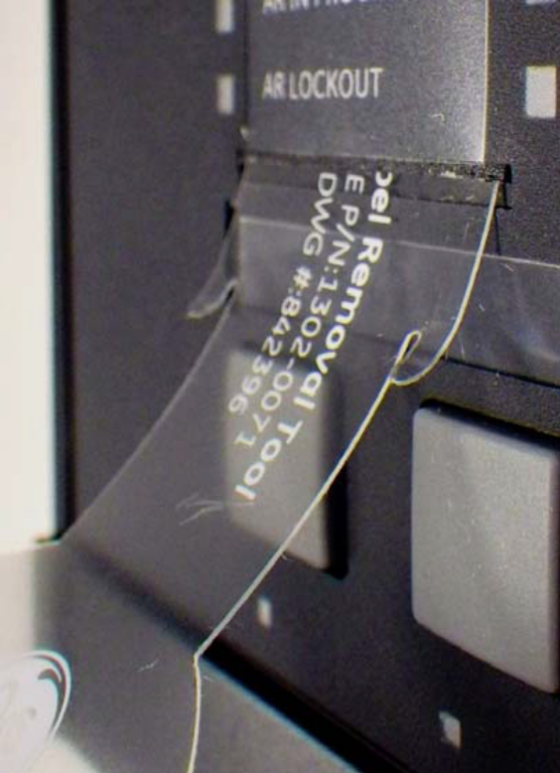
- Remove the tool with the LED label.
- Slide the printed custom LED labels up into the LED label slots.

Pushbutton Label Replacement
The following procedure describes how to replace the pushbutton label using the label removal tool.
- Slide the label tool under the user-programmable pushbutton label as shown in the next image. Make sure the bent tab is pointing away from the relay.

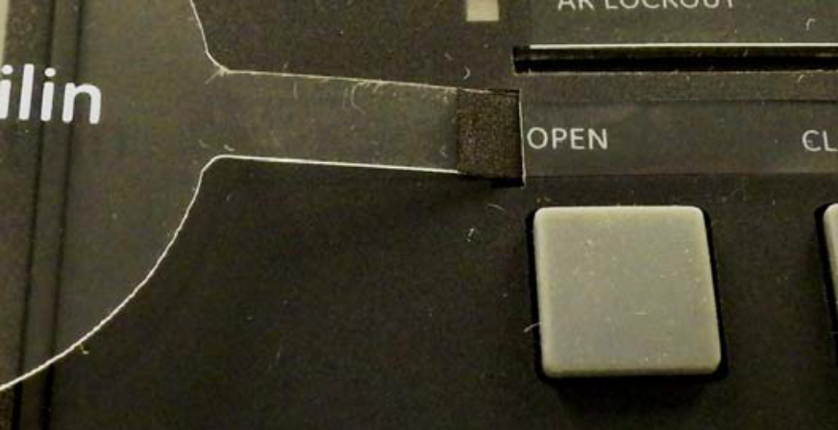
- Remove the tool and user-programmable pushbutton label.
- Slide the printed custom pushbutton label into the pushbutton label slot.

