

8 Series - 859

859

User-Programmable LED/Pushbutton Template Technical Note
Publication reference: GET-20111
Copyright © 2025 GE Vernova

Description
The 859 faceplate provides two columns of 7 LED indicators, and 3 LED pushbutton indicators. The “IN SERVICE” (LED 1) is non-programmable, and all other LEDs are configurable. Three pushbuttons are available for programming. Refer to the instruction manual for additional details.
The user-programmable LEDs provide an easy method of displaying digital information (ON, OFF) from FlexLogic™ operands. Typical applications include breaker status and protection element status.
The user-programmable pushbuttons provide an easy and error-free method of entering digital state (ON, OFF) information. Typical applications include breaker control and setpoint group changes.
The user-programmable LEDs and pushbuttons have default names pre-printed on the faceplate within the windows. Inserting new labels into the windows will show the custom names printed from the templates.

Template
The user-programmable LED and user-programmable pushbutton templates are shown on the following pages. Click on the text fields within each label to edit. Each line of text should not exceed the label width limits. The labels are sized to align with the LEDs.
When the custom labels text entry is completed, save this document to a secure location before printing.

The 859 comes with a label removal tool for removing the LED labels and pushbutton label. Read on for detailed instructions.

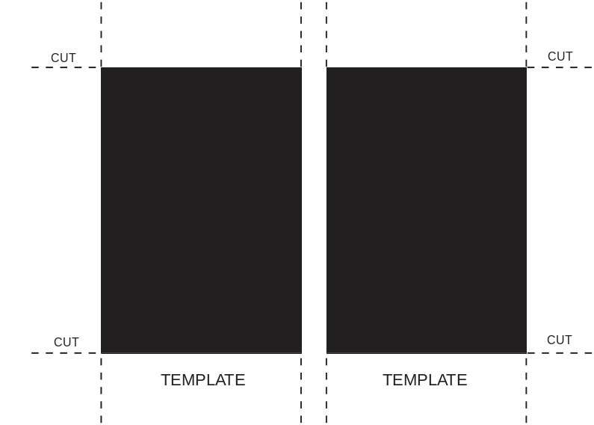
IN SERVICE
LED 2
LED 3
LED 4
LED 5
LED 6
LED 7

LED 8
LED 9
LED 10
LED 11
LED 12
LED 13
LED 14

Figure 1: 859 User-Programmable LED template

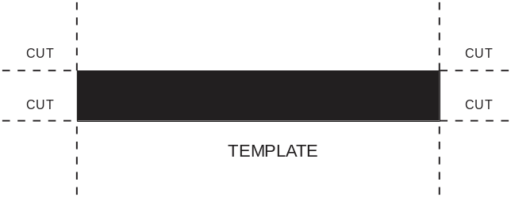
PB3

PB2

PB1

Figure 2: 859 User-Programmable Pushbutton template

LED Label Replacement
The following procedure describes how to replace the LED labels using the label removal tool.
- Bend the tabs of the tool upwards as shown in the image.

- Slide the label removal tool under the LED label as shown in the next image. Make sure the bent tabs are pointing away from the relay. Move the tool inside until the tabs enter the pocket.
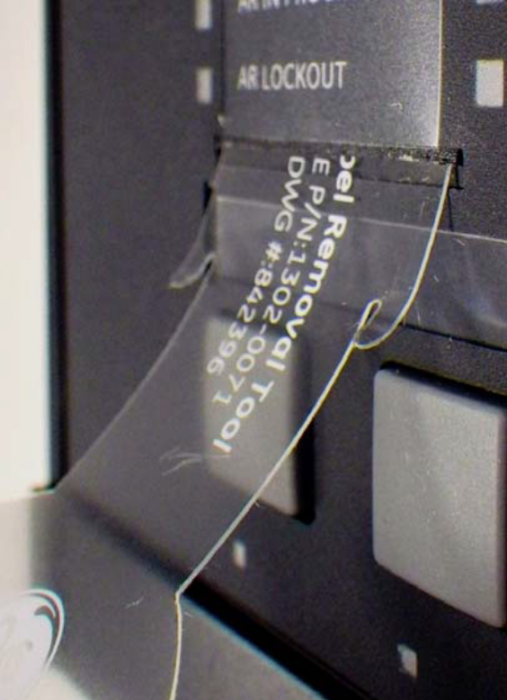
- Remove the tool with the LED label.
- Slide the printed custom LED labels up into the LED label slots.

Pushbutton Label Replacement
The following procedure describes how to replace the pushbutton label using the label removal tool.
- Slide the label tool under the user-programmable pushbutton label as shown in the next image. Make sure the bent tab is pointing away from the relay.
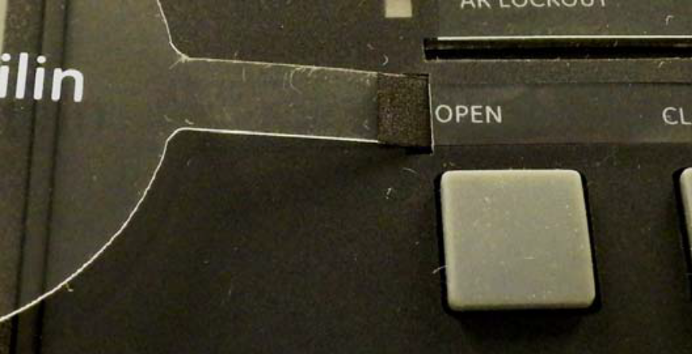
- Remove the tool and user-programmable pushbutton label.
- Slide the printed custom pushbutton label into the pushbutton label slot.

For further assistance
For product support, contact the information and call center as follows:

GE Vernova
650 Markland Street
Markham, Ontario
Canada L6C 0M1
Worldwide telephone: +1 905 927 7070
Europe/Middle East/Africa telephone: +34 94 485 88 54
North America toll-free: 1 800 547 8629
Fax: +1 905 927 5098
Worldwide e-mail: GA.support@gevernova.com
Website: https://www.gevernova.com/grid-solutions/multilin/

