
UR Family
UR Relays Percent Differential Element Testing
Application Note
Publication reference: GET-20105A
Copyright © 2025 GE Vernova
Republished in GE Vernova brand: 2025

This document outlines testing of the UR relays Percent Differential element and results. Although content below is shown for the B90 relay for illustration purposes, it’s fully applicable to all UR platform percent differential relays, B30, B90, G30, G60, M60, T35 and T60 having the same algorithm.

Introduction
The B90 Low Impedance Bus Differential System is part of the GE Universal Relay (UR) product family.
The B90 provides protection and metering for busbars with up to 24 feeders. It provides multi-zone differential protection with both restrained (percent, biased) and unrestrained (unbiased, instantaneous) functions incorporated, together with the phase comparison operating principle. Low and high breakpoints are connected together with a cubic spline function to provide a smooth transition between slope 1 and slope 2. If testing of points along this region is required, use the 87T Characteristics.xlsx spreadsheet.
Figure 1: Biased operating characteristics
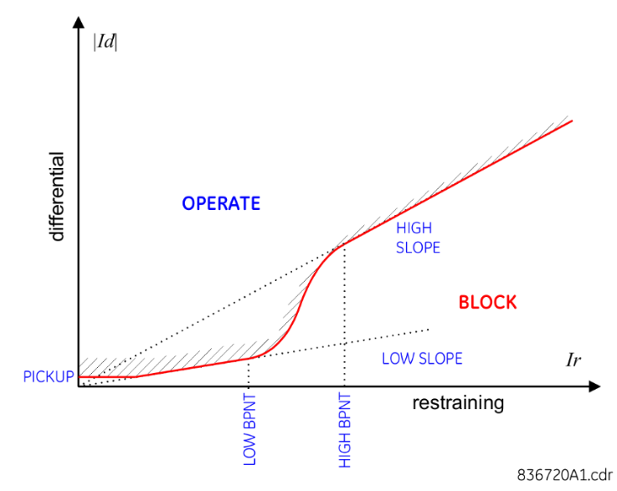

The differential signal is composed of the sum of individual feeder currents.
$$I_{\text{DIF}}=\left|I_{1}+I_{2}+\text{.}\text{.}\text{.}+I_{n}\right|$$
The restraint quantity is chosen to be the maximum of the individual feeder currents.
$$I_{\text{RES}}=\text{max}\left(\left|I_{1}\right|, \left|I_{2}\right|, \text{.}\text{.}\text{.},\left|I_{n}\right|\right)$$
The biased operation has two FlexLogic operands, BUS 1 BIASED PKP and BUS 1 BIASED OP. The pickup (PKP) operand responds to the characteristic shape. The operate (OP) operand responds to the characteristic shape AND the directional principle or the characteristic shape and NO saturation detected.
Figure 2: Biased pickup and operate

The differential and restraint quantities can be plotted on the biased operating characteristic curve. Since the relay also uses the directional principle, the biased trip may not occur when the two points intercept the curve. To test the curve, assign the FlexLogic BUS 1 BIASED PKP operand to an output that is used for sense on the test set.
The directional principle responds to the relative direction of the fault currents; therefore, no reference signal is required. The directional principle declares that
- If at least one fault current flows in the same direction, compared with the sum of the remaining currents, the fault is internal, or
- If at least one fault current flows in an opposite direction compared with the sum of the remaining currents, the fault is external
The current is determined to be a fault current if the magnitude is greater than an adaptable threshold based on the restraint current and the number of feeders in the bus. The current is considered if its magnitude is greater than K * I_{rest} or 2 times the CT rating. For bus zones with two feeders K = 0.2, for bus zones with three to six feeders K = 0.8 / (N - 1). For bus zones with more than six feeders K = 0.16. This is important when testing the directional principle supervision.

Setup
The example in this document tests a B90 with six zones each with a 2000:5 CT on each CT input. The following settings are used.
Figure 3: Bus differential settings
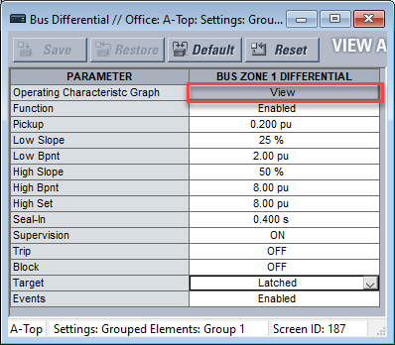

The View button (shown in red outline) at the top of the settings opens a live view of the element.
Figure 4: Bus differential characteristic view
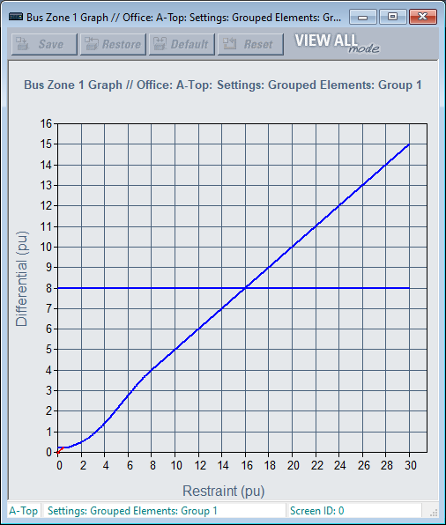

Zoom into regions of the graph by clicking and holding the left mouse button on the graph and expanding the window.
Figure 5: Zoomed-in bus differential characteristic view
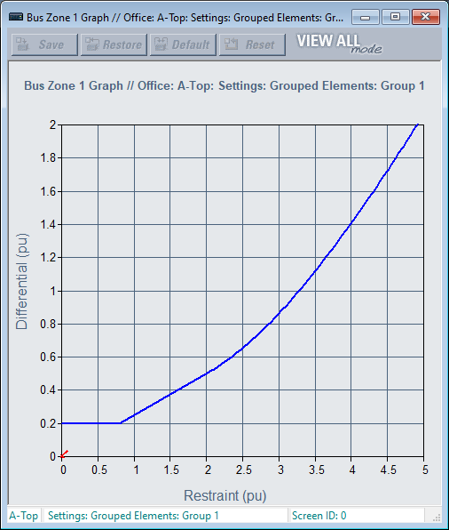

Set the trip output or spare output wired to test set sense to BUS 1 BIASED PKP to test the shape of the dual slope characteristic.
Figure 6: Output contact setting pickup
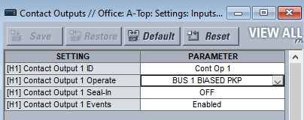

Note: The current inputs have a continuous rating of 4 x Inom. Do not exceed 4 x Inom current continuously during testing, else damage to the relay occurs
The characteristic accuracy is ±3% of the maximum circuit current or ±2% of rated, whichever is greater.

Pickup test
The pickup is set at 0.2 pu, which makes the operate current 0.2 * 5 = 1 A. The per unit value is based on the largest CT primary rating. In this case, because all the CTs are 2000:5, the pickup is 0.2 * 2000 on the primary or 0.2 * 5 on the secondary.
To test the pickup value, use a pulsed linear ramp test starting with two equal currents 180° apart. Then increase or decrease one of the currents until the test set receives a sense.
- Set the initial values to 2 A on each source, one set to 0° and the other set to 180°. This results in zero differential current.
- Set the pulse duration to 50 ms with a wait time of 50 ms.
- Set the delta current to -0.01 A with a current limit of 0 A.
- Select current source 2 as your action source.
- Start the test.
Figure 7: Pickup test pulsed ramp setup
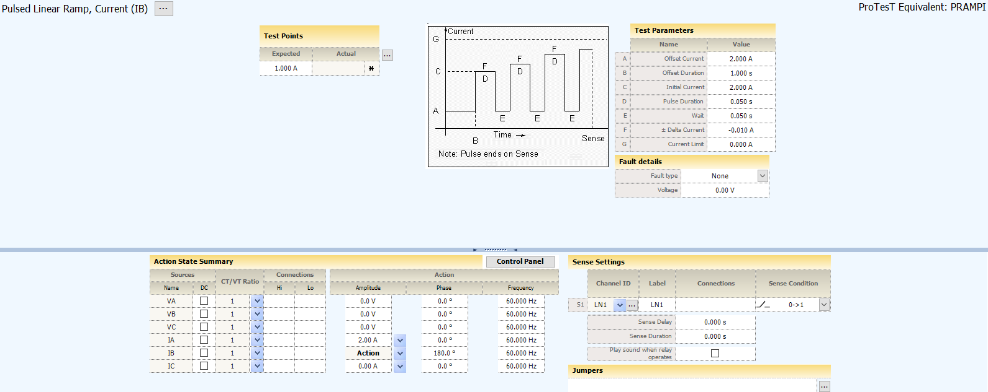

View the test points live on the Operating Characteristic Graph View. The restraint current is the maximum, 1 A in this case, which is 0.4 pu. The red X starts at (0.4,0) and rises to the differential characteristic.
Figure 8: Pickup test view
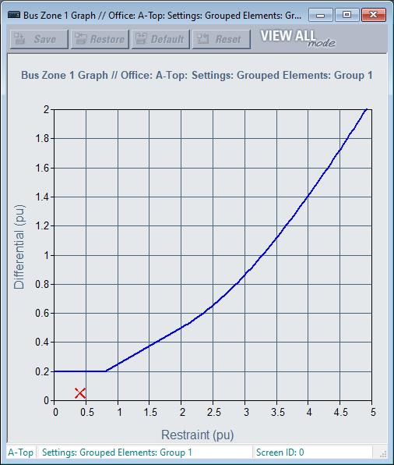

Figure 9: Pickup test result
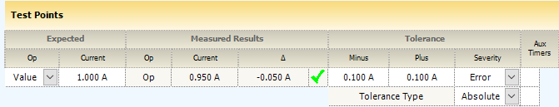

Accuracy is ±2% of 5 A, or 0.100 A.

Slope 1 test
Slope 1 can be checked in a similar way because the restraint quantity is less than the continuous amp limit of the relay.
The settings have a 25% slope with a low breakpoint of 2 pu. Choosing a restraint of 1.5 pu results in a (required differential current of 1.5 * 0.25 = 0.375 pu. The current on source 2 must then be
(1.5 - 0.375) * 5 = 5.63 A.
To test slope 1, use a pulsed linear ramp test starting with equal currents 180° apart. Increase or decrease one of the currents until the test set receives a sense.
- Set the initial values to 7.5 A on each source, one set to 0° and the other set to 180°.
- Set the pulse duration to 50 ms with a wait time of 50 ms.
- Set the delta current to -0.01 A with a current limit of 0 A.
- Select current source 2 as your action source.
- Start the test.
Figure 10: Slope 1 test pulsed ramp setup
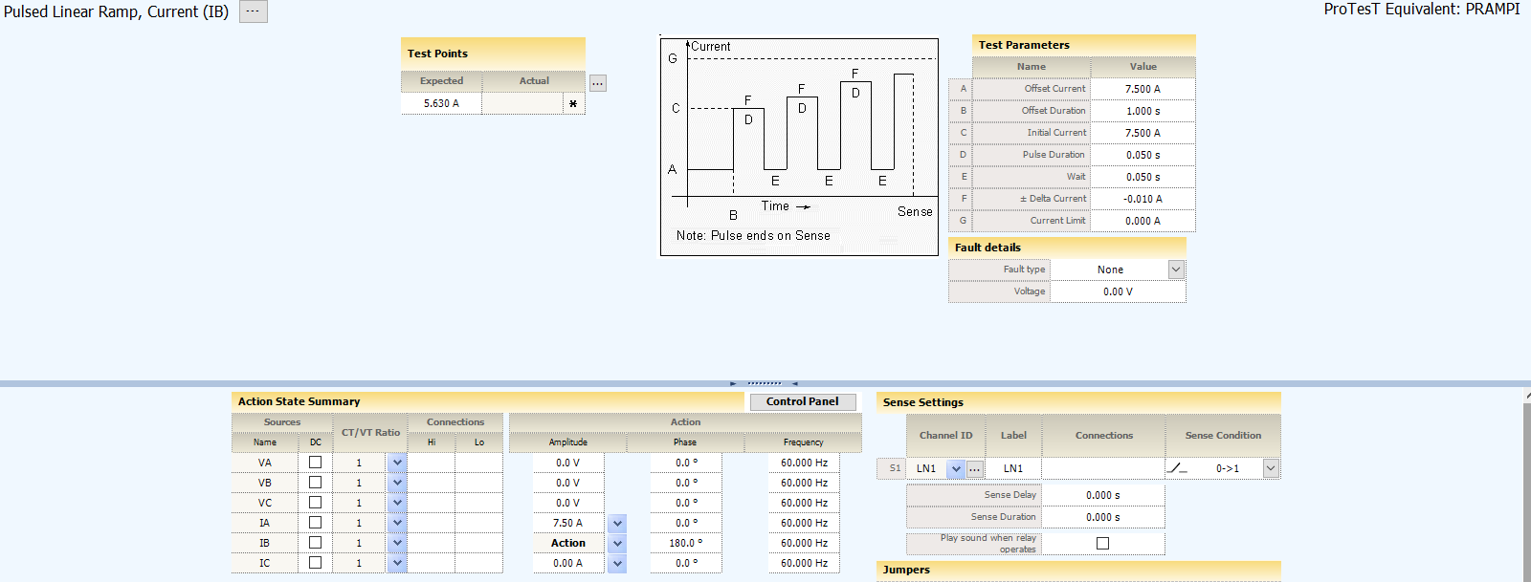

Figure 11: Slope 1 test view
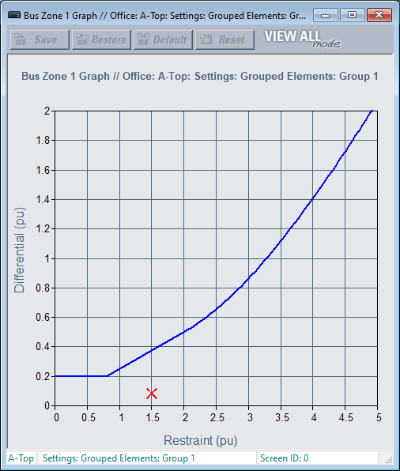

Figure 12: Slope 1 test results
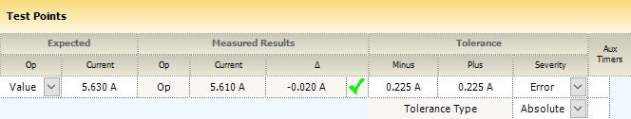

Accuracy is ±3% of 7.5 A, or 0.225 A.

Slope 2 test
Slope 2 begins at breakpoint 2, which is set at 8.0 pu and the slope is 50%. Since 8.0 pu is above the 4.0 pu continuous rating of the input, a test cannot hold the restraint current at 40 A. Test set source limitations also can come into play, requiring the user to parallel sources to get the higher magnitude currents.
For slope 2, the restraint quantity needs to be 8 pu or 40 A. The test requires using two paralleled sources each set at half of the test value. The differential current needs to be 50%, so
Source 2 = 8 (1 - 0.5) * 5 = 20 A.
To test slope 2, use a pulsed linear ramp with three sources. Fix one source at 180° and the other two at 0°, then increase their magnitudes until the test set receives a sense.
- Parallel sources 1 and 3 going into the relay.
- Set the initial values to 10 A on sources 1 and 3, set to 0°, and source 2 set to 20 A and 180°.
- Set the pulse duration to 50 ms with a wait time of 50 ms.
- Set the delta current to 0.1 A with a current limit of 25 A.
- Select current sources 1 and 3 as your action sources.
- Start the test.
Figure 13: Slope 2 pulsed ramp setup
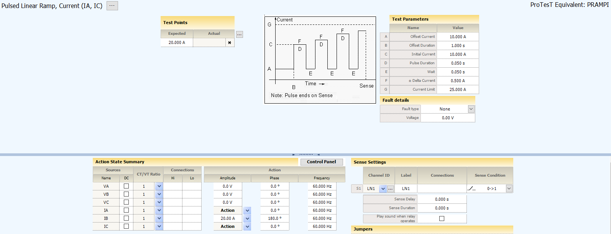

Figure 14: Slope 2 test view
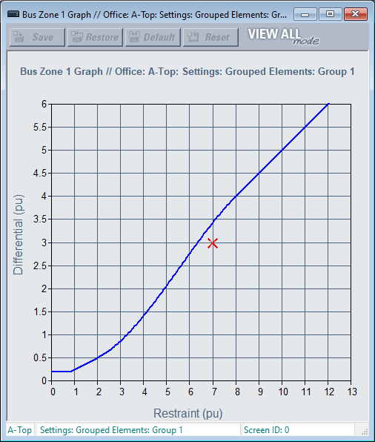

Figure 15: Slope 2 test results
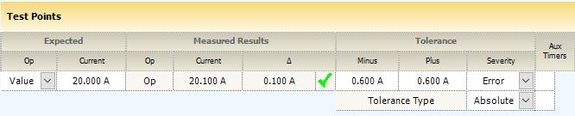

Accuracy is ±3% of -0 A, or -1.20 A, but because we have current from two sources it is half, or 0.600 A.

Directional principle check
Now that the characteristic has been verified, the trip operation can be verified quickly by injecting currents that meet the operate conditions.
First, change the output operate being used for test set sense to BUS 1 BIASED OP.
Figure 16: Output contact setting OP
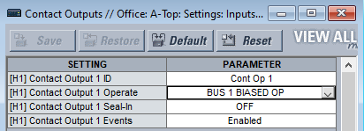

If a restraint value of 15 A or 3 pu is chosen, because there are six feeders in this relay’s bus zone, K = 0.16 so source 2 current is 15 * 0.16 = 2.4 A. Use the pulsed ramp test for this.

 | In firmware released after April 2021, the B90 uses an extra protection security enhancement that requires the relay to detect an actual fault disturbance to operate. The fault detection algorithm uses a rate of change of current algorithm to distinguish a fault from non-fault conditions.

- Set the initial values to 15 A on source 1, set to 0°, and the other set to 180°.
- Set the pulse duration to 50 ms with a wait time of 50 ms.
- Set the delta current to -0.05 A with a current limit of 0 A.
- Select current source 2 as your action source with an initial value of 5A.
- Start the test.
Figure 17: Directional principle check settings
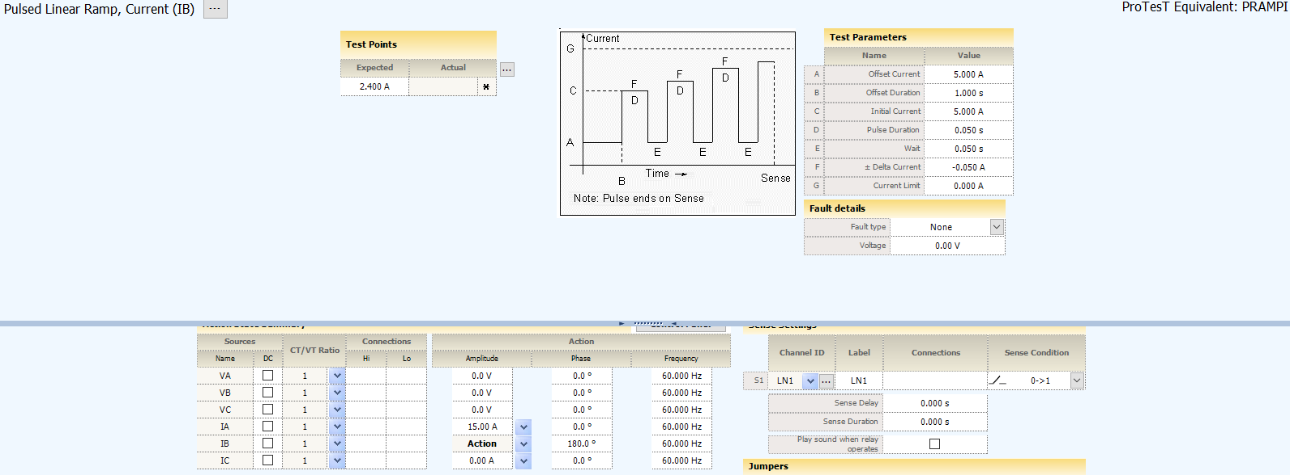

The relay operates when the source 2 current gets to 2.4 A.
Figure 18: Directional principle test view
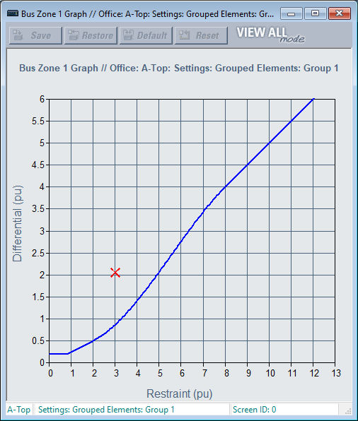

Figure 19: Directional principle test results
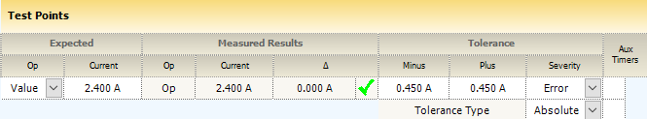

Accuracy is ±3% of 15 A, or 0.450 A.

For further assistance
For product support, contact the information and call center as follows:

GE Vernova
650 Markland Street
Markham, Ontario
Canada L6C 0M1
Worldwide telephone: +1 905 927 7070
Europe/Middle East/Africa telephone: +34 94 485 88 54
North America toll-free: 1 800 547 8629
Fax: +1 905 927 5098
Worldwide e-mail: GA.support@gevernova.com
Website: https://www.gevernova.com/grid-solutions/multilin/

